A sample of impure CaCO3 weighing 0.245g is dissolved in 100mL of standardised 0.0905mol/L HCl solution. After the reaction is complete, it's found that the excess acid required 17mL of NaOH solution for complete neutralisation using phenolphthalein as an indicator. Earlier it was found 25mL of NaOH solution required an average 69mL of standardised HCl solution for a bromothymol blue indicator to change colour. Find the % of CaCO3 in the impure sample.

[10 marks]

NaOH + HCl → NaCl + H2O

n(HCl) = 0.069 x 0.0905 = 0.00624mol

n(NaOH) excess in 25mL = n(HCl) = 0.00624mol

n(NaOH) reacted with excess acid = 0.00624 x $\frac{17}{25}$ = 0.00425mol

n(HCl) excess = n(NaOH) reacted with excess acid = 0.00425mol

n(HCl) initial = 0.1 x 0.0905 = 0.0905mol

n(HCl) reacted = 0.00480mol

CaCO3 + 2H3O+ → Ca2+ + CO2 + 3H2O

n(H3O+) = n(HCl) = 0.00480mol

n(CaCO3) = 0.00480 x 0.5 = 0.00240mol

m(CaCO3) = 0.00240 x M(CaCO3) = 0.240g

% purity = $\frac{0.240}{0.245}$ x 100 = 98.12% = 98%

Answer: ~98%

10mL of 0.1mol/L NaOH is added to 3mL of 0.05mol/L H2SO4. Calculate the pH of the resultant solution (assume 100% ionisation of H2SO4).

[7 marks]

2NaOH + H2SO4 → Na2SO4 + 2H2O

n(NaOH) = 0.1 x 0.01 = 0.001mol

mol ratio (NaOH) = $\frac{n(NaOH)}{2}$ = $\frac{0.001}{2}$ = 0.0005mol

n(H2SO4) = 0.05 x 0.003 = 0.00015

mol ratio (H2SO4) = = = 0.00015mol

Hence NaOH is the LR as less is present on a mol-to-mol basis

n(NaOH) reacted = n(H2SO4) x 2 = 0.0003mol

n(NaOH) left = 0.0007mol

n(OH–) left = n(NaOH) = 0.0007mol

[OH–] = $\frac{0.0007}{0.01+0.003}$ = 0.0538mol/L

pOH = 1.27

pH = 12.7

Answer: 12.7

**Electrolytes**

Electrolyte: A substance that dissolves in water and forms ions.

Strong electrolytes are good conductors of electricity in aqueous solution because water causes them to dissociate (ionic substances) or completely ionise (covalent molecular substances). Strong acids and ionic substances are strong electrolytes.

Weak electrolytes are poor conductors of electricity in aqueous solution. Only a small percentage of molecules ionise/dissociate when dissolved in water and so only a small concentration of ions is produced to conduct charge. Weak acids and weak covalent molecular bases tend to be weak electrolytes.

Non-electrolytes are non-conductors of electricity because no ions are produced when they dissolve in water.

**Self-Ionisation of Water**

$$H_{2}O_{ \left(l\right)}⇌{H^{+}}_{\left(aq\right)}+{{OH}^{-}}_{\left(aq\right)}$$

or

$$2H_{2}O_{ (l)}⇌H_{3}{O^{+}}_{(aq)}+{{OH}^{-}}_{(aq)}$$

In water at 25°C, [H+]=[OH–] so the water is neutral (both are 1.00 x 10-7mol L-1).

Equilibrium constant for the self-ionisation of water: Kw = [H+][OH–] = [H3O+][OH–]

Kw = 1.00 x 10-14 at 25°C.

The self-ionisation of water is an endothermic process. An increase in temperature will favour the endothermic (forward) reaction which would result in an increased equilibrium constant. (e.g., at 40 °C, Kw = 2.916 ×10-14).

Similarly, at lower temperatures, the exothermic (reverse) reaction is favoured and so the equilibrium constant is reduced (e.g., at 10 °C, Kw = 2.93 ×10-15).

If it’s pure water, no matter what the value of Kw is, [H+]=[OH–].

Since [H3O+][OH–] = 1.00 ×10-14, for all solutions at 25 °C, the concentration of one of these ions can be calculated given the concentration of the other.

|  |  |
| --- | --- |
| Acidic solutions | [H+] > [OH–] |
| or | [H+] > 1.00 x 10-7mol L-1 at 25°C |
| and | [OH–] < 1.00 x 10-7mol L-1 at 25°C |
| Basic solutions | [H+] < [OH–] |
| or | [H+] < 1.00 x 10-7mol L-1 at 25°C |
| and | [OH–] > 1.00 x 10-7mol L-1 at 25°C |
| Neutral solutions | [H+] = [OH–] |
| or | [H+] = 1.00 x 10-7mol L-1 at 25°C |
| and | [OH–] > 1.00 x 10-7mol L-1 at 25°C |

Acidity constant (Ka) and acid strength:

An acid- base transfer reaction is an example of an equilibrium process. The extent to which an acid ionises in aqueous solutions can be determined from the equilibrium constant Ka also known as the acidity constant. It is a measure to which the proton transfer goes to completion.

The larger the Ka the greater the tendency of the acid to donate a proton to water i.e., the stronger the acid is the greater the degree of its ionisation.

A Ka value at 25°C of 1.8 x 10-5 indicates the reaction only proceeds to a very limited extent and only about 1% of ethanoic acid molecules are ionised.

The larger the value of Ka the more the equilibrium position favours products, hence the greater the tendency of the acid to form hydronium ions and so the stronger the acid is.

The Ka value also indicates the strength of the acid’s conjugate base to accept a proton back from water so, if Ka is large (strong acid) its conjugate base is weak. As Ka is progressively smaller, the acid is progressively weaker, and the conjugate base becomes progressively stronger. (The stronger the acid is the weaker its conjugate-base).

Even though pure water at temperatures above 40 °C has a pH less than 7, it isn’t acidic (this is because a neutral pH of 7 only applies at 25 °C). Pure water at, whatever temperature, is always neutral because the [H3O+]=[OH–].

pH = –log10 [H+]

An increase in pH by 1 means that the solution is only $\frac{1}{10}$ as acidic.

**Theories on Acids & Bases**

Arrhenius theory:

* Acids have H in their formula and produce hydrogen ions in aqueous solution.
* Bases have OH in their formula and produce hydroxide ions in aqueous solution.
* Neutralisation occurs when H+ ions and OH– ions combine to form H2O (l).
* Limited to aqueous solutions.

Problems with the theory:

* Some bases produce OH− ions in solution yet do not have OH in their formula (eg NH3 and CO32-).
* Restricted to aqueous solutions.
* Not all salts are neutral.
* Does not allow for the existence of hydronium ions (H3O+).

Bronsted-Lowry theory:

* Acids act as proton (H+) donors.
* Bases act as proton (H+) acceptors.

HCl (aq) + NH3 (aq) ⇌ NH4+(aq) + Cl–(aq)

HCl is acting as an acid by donating a proton to NH3. NH3 is acting as a base as it’s accepting a proton from H2O.

H2O (l) + NH3 (aq) ⇌ NH4+(aq) + OH–(aq)

H2O is acting as an acid by donating a proton to NH3. NH3 is acting as a base as it’s accepting a proton from H2O.

H2PO4 (aq) + H2O (l) ⇌ HPO42–(aq) + H3O+(aq)

H2PO4 is acting as an acid by donating a proton to H2O. H2O is acting as a base as it’s accepting a proton from H2PO4.

Neutralisation: Reaction between a proton donor and a proton acceptor.

e.g., HCO3–(aq) + H2O (l) ⇌ H2CO3 (aq) + OH–(aq)

When an acid donates a proton, it has the potential to act as a base, hence the substance formed is its conjugate base. When a base accepts a proton, it has the potential to act as an acid, hence the substance formed is its conjugate acid.

The acid and the base it forms (or the base and the acid it forms) are called a conjugate acid-base pair.

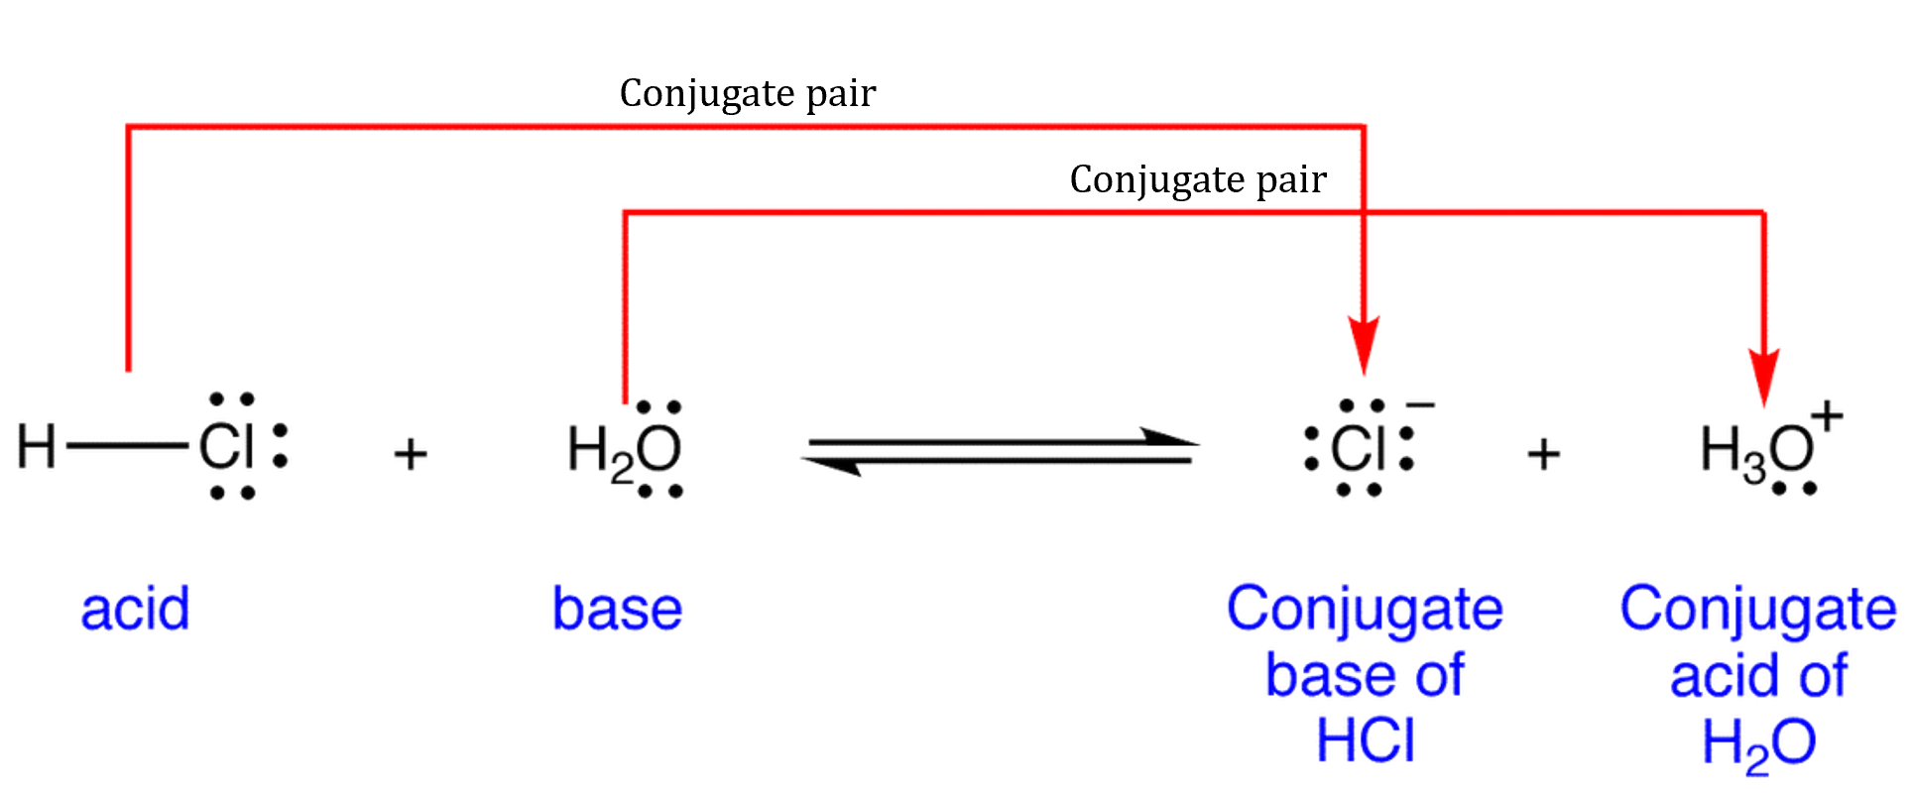

In any conjugate acid- base pair the formula of the acid is always greater by the equivalent of H+.

The stronger the acid the weaker its conjugate base.

**Acids & Bases**

Strong acids completely ionise in water (e.g., HCl (aq) → H+(aq) + Cl–(aq)).

Weak acids partially ionise in water (e.g., CH3COOH (aq) ⇌ H+(aq) + CH3COO–(aq)).

|  |  |
| --- | --- |
| Strong acids: | Weak acids: |
| Hydrochloric acid (HCl) | Oxalic acid (H2C2O4) |
| Sulfuric acid (H2SO4) | Phosphoric acid (H3PO4) |
| Nitric acid (HNO3) | Hydrofluoric acid (HF) |
| Hydrobromic acid (HBr) | Ethanoic acid (CH3COOH) |
| Hydroiodic acid (HI) | Carbonic acid (H2CO3) |
| Perchloric acid (HClO4) | Hypochlorous acid (HClO) |

Strong bases completely dissociate in water to produce hydroxide ions (e.g., NaOH (aq) → Na+(aq) + OH–(aq)).

Weak bases partially dissociate in water to produce hydroxide ions (e.g., NH3 (aq) + H2O (l) ⇌ NH4+(aq) + OH–(aq)).

|  |  |
| --- | --- |
| Strong bases: | Weak bases: |
| Soluble: | Ammonia (NH3) |
| Sodium hydroxide (NaOH) | Carbonate ion (CO32–) |
| Potassium hydroxide (KOH) | Ethanoate ion (CH3COO–) |
| Slightly soluble: | Fluoride ion (F–) |
| Calcium hydroxide (Ca(OH)2) | Phosphate ion (PO43–) |
| Magnesium hydroxide (Mg(OH)2) |  |

**Hydrolysis of Salts**

Hydrolysis: The process in which an ion reacts with water to produce H3O+ or OH– ions. Ions that produce H3O+ ions are said to be acidic while ions that produce OH– are said to be basic.

|  |  |  |  |
| --- | --- | --- | --- |
|  | Acidic: | Basic: | Neutral: |
| Anion | HSO4–, H2PO4– | Other anions | Cl–, NO3–, I–, Br– |
| Cation | NH4+, Fe3+, Sn4+, Cr3+, Al3+ | Not common | Na+, Li+, Mg2+, K+, Ca2+, Ba2+ |

|  |  |
| --- | --- |
| Acidic anions | HSO4– and H2PO4–  (i.e., anion from a polyprotic acid) |
| Basic anions | CH3COO–, HPO42–, PO43–, SO42–, HCO3–, CO32–, ClO–, HS–, CN–, S2–, F–  (anions from a weak acid) |
| Neutral anions | Cl–, NO3–, Br –, I–  (anions from strong acids) |
| Acidic cations | NH4+, Al3+, Fe3+, Cr3+  (cation from a weak base or from aquated metal ions) |
| Basic cations | None covered in the syllabus |
| Neutral cations | Na+, K+, Ca2+, Mg2+, Li+, Ba2+  Group I and II metal cations |

Acid-base reactions tend to occur in the direction in which the stronger acid and stronger base react to form a weaker acid and weaker base e.g.,

HNO3 (aq) + H2O (l) H3O+(aq) + NO3–(aq)

Equilibrium lies to the right.

HCN (aq) + H2O (l) H3O+(aq) + CN–(aq)

Equilibrium lies to the left.

Monoprotic acids can donate only one proton (hydrogen ion) per molecule (CH3COOH).

While weak monoprotic acids produce fewer hydrogen ions in solution than strong acids, they react to the same extent with bases provided concentration is the same.

Diprotic acids contain 2 acidic protons per molecule.

Q: Explain (using equations) why one mole of H2SO4 yields between one and two moles of H3O+ ions in solution.

H2SO4 (aq) + H2O (l) → HSO4–(aq) + H3O+(aq)

HSO4–(aq) + H2O (l) ⇌ SO42–(aq) + H3O+(aq)

Successive ionisation: The process of becoming ions over multiple steps.

Polyprotic acids contain 2 or more acidic protons per molecule.

Q: Use equations to show the successive ionisation of phosphoric acid.

H3PO4 (aq) + H2O (l) ⇌ H2PO4–(aq) + H3O+(aq)

H2PO4–(aq) + H2O (l) ⇌ HPO42–(aq) + H3O+(aq)

HPO42–(aq) + H2O (l) ⇌ PO43–(aq) + H3O+(aq)

**Acid-Base Properties of Salts**

Acid + base → salt + H2O

Although this is called a neutralisation reaction, the salt formed isn’t always neutral. An ion present in the salt can donate (becoming acidic) or accept (becoming basic) a proton via reacting with water so can be acidic or neutral depending on the reaction.

The reaction of the ions with water is called hydrolysis.

**Buffer Solutions & Buffer Capacity**

Buffer solution: A mixture of a weak acid and its conjugate base or of a weak base and its conjugate acid.

Buffer solutions can maintain a relatively constant pH when quantities of acidic or basic materials are added to them.

They are often prepared by adding the salt of the conjugate acid or base to the weak base or acid (respectively).

For a buffer to work, the amount of weak acid and its conjugate base must be large compared to the amount of H+ and OH– added or removed.

Buffer capacity: The ability of the buffer to resist change changes in pH. It refers to the amount of H+ or OH– that can be added without causing a 1 unit change to the pH of the buffer solution.

Buffering capacity increases as the concentration of the acid/conjugate base pair increases. The greater the concentration of the acid/conjugate base pair, the greater the amount of H+ or OH– that can be added without overwhelming the buffer’s capacity to maintain a constant pH.

Q: A buffer solution was made by dissolving enough CH3COOH and NaCH3COO in water to produce a solution that contained 0.4mol of CH3COOH and 0.2mol of CH3COO–.

CH3COOH (aq) + H2O (l) ⇌ CH­3COO–(aq) + H3O+(aq)

[a] Would the buffer operate within its capacity if 0.01mol of NaOH was added?

0.01mol of NaOH would neutralise 0.01mol of H3O+. The forward reaction would be favoured to partially counteract this change. As there’s 0.4mol of CH3COOH available for the production of H3O+ (as per the forward reaction) the buffer would be operating within its capacity and be able to maintain a constant pH.

[b] Would the buffer operate within its capacity if 0.5mol of NaOH was added?

0.5mol of NaOH would neutralise 0.5mol of H­3O+. The forward reaction would be favoured to partially counteract this change. As there’s 0.4mol of CH3COOH available for the production of H3O+ (as per the forward reaction) the buffer would be overwhelmed. It wouldn’t have sufficient moles of CH3COOH to replace the H3O+ consumed by the NaOH. The pH of the buffer solution would change markedly.

Exercise tends to increase the acidity of blood. The presence of H2CO3 and its conjugate base HCO3– help to maintain the blood’s pH at 7.4.

H2CO3 (aq) + H2O (l) ⇌ HCO3– + H3O+(aq)

H2CO3 (aq) ⇌ H2O (l) + CO2 (g)

During exercise, more H3O+ is released into the blood from the muscles. Le Châtelier’s principle predicts that the reverse reaction would be favoured to counteract the increased [H3O+] and effectively maintain a relatively constant blood pH.

2mol of ethanoic acid (CH3COOH) is mixed with with 2mol sodium ethanoate (NaCH3COO) and making the solution volume up to 1.00L. This solution contains a high concentration of weak acid, CH3COOH, and its conjugate base, CH3COO- (from NaCH3COO).

The equilibrium set up is given as:

CH3COOH(aq) + H2O(l) H3O+(aq) + CH3COO−(aq)

Q: Explain buffering using collision theory.

If acid is added to the system this increases the H+/ H3O+ concentration.

This increases the frequency of collisions between H3O+ and CH3COO‒ and so increases the rate of the reverse reaction relative to the forward reaction.

This will consume H+/ H3O+ and reduce their concentration.

(While this occurs the concentration of the reactants is increasing and so the rate of the forward reaction increases until the rates of the forward and reverse reactions are the same and) equilibrium is re- established where H3O+ concentration is very close to what it was originally maintaining pH.

If base is added to the system this decreases the H+/ H3O+ concentration.

This reduces the frequency of collisions between H3O+ and CH3COO‒ and so reduces the rate of the reverse reaction relative to the forward reaction.

This will increase the H+/ H3O+ concentration.

(The rate of the reverse reaction then increases until the rates of the forward and reverse reactions are the same and) equilibrium is re- established where H3O+ concentration is very close to what it was originally maintaining pH.

The buffer capacity of a solution depends on 2 factors:

1. The relative concentrations of the weak acid (base) and its conjugate base (acid) – equal concentrations of these two offers the best buffering capacity.
2. The concentration of the weak acid (base) and its conjugate base (acid) – the greater the concentrations (in general) the greater the buffering capacity.

**Acid-Base Titrations**

Titration: The procedure of adding one solution to the other for a complete reaction.

2 types of titrations:

1. Acid-base titrations.
2. Redox titrations.

The point at which the acid-base reaction is complete is called the equivalence point when reactants are in stoichiometric proportions. This is often visible as acids and bases are colourless, so an indicator or pH meter is required.

Since the products of an acid-base reaction may be acidic, basic or neutral, it’s important to choose an indicator so that the end point matches the equivalence point. An appropriately chosen indicator will show a colour change (end point) when the reaction is complete (equivalence point). A pH meter can also be used.

Indicators are weak acids or bases whose colour changes as they change to their conjugate form. They’re chosen so that this colour change occurs at equivalence point.

|  |  |  |  |
| --- | --- | --- | --- |
| Indicator: | pH range: | Colour change acid/base: | Suitable for: |
| Methyl orange  Bromophenol blue | 3.1–4.4  4–4.6 | Red → yellow  Yellow → purple | Strong acid + weak base |
| Methyl red | 4.2–6.3 | Red → yellow | Strong acid + strong base |
| Phenolphthalein | 8.3–10 | Colourless → pink | Weak acid + strong base |

The pH of solutions of salts depends on the relative strengths of the anion as a base and the cation as an acid. Salts produced by reactions between a weak acid and weak base are very close to neutral. The equivalence point is not distinct (no great change in pH). As such, a pH meter is definitely the more preferred choice to monitor this type of acid-base titration.

|  |  |  |  |
| --- | --- | --- | --- |
| Indicator: | Colour in acid: | Colour in base: | pH range: |
| Universal indicator | Red | Purple | 0–14 |
| Methyl orange | Red | Yellow | 3.1–4.4 |
| Bromophenol blue | Yellow | Purple | 3–4.6 |
| Methyl red | Red | Yellow | 4.4–6.2 |
| Litmus | Red | Blue | 4.5–8.3 |
| Bromothymol blue | Yellow | Blue | 6–7.6 |
| Phenolphthalein | Colourless | Pink | 8.3–10 |
| Alizarine yellow R | Yellow | Red | 10.2–12 |

For an indicator (which is a weak acid) in solution, the following reaction takes place:

HIn (aq) H+(aq) + In–(aq)

The colour changes are due to the difference in the colours of HIn and In–.

A primary standard is required to establish the concentration of unknown solutions. Its concentration must be accurately known. To be a useful indicator, the end point should match the equivalence point.

Characteristics of a primary standard:

* High degree of purity and known formula.
* Stable – Doesn’t decompose in air or react with gases in air e.g., CO2, N2, O2, etc.
* Relatively high molar mass – to minimise weighing errors (minimising percentage uncertainty).
* Soluble in water.
* The reactions it’s involved in are known.
* Not hygroscopic (absorbs water from the atmosphere) or deliquescent (absorbs so much water from the atmosphere that it eventually dissolves in the water it absorbs).

2 commonly used primary standards are anhydrous sodium carbonate (Na2CO3), potassium hydrogen phthalate (KHC8H4O4) and hydrated oxalic acid (H2C2O4).

Standardising solutions:

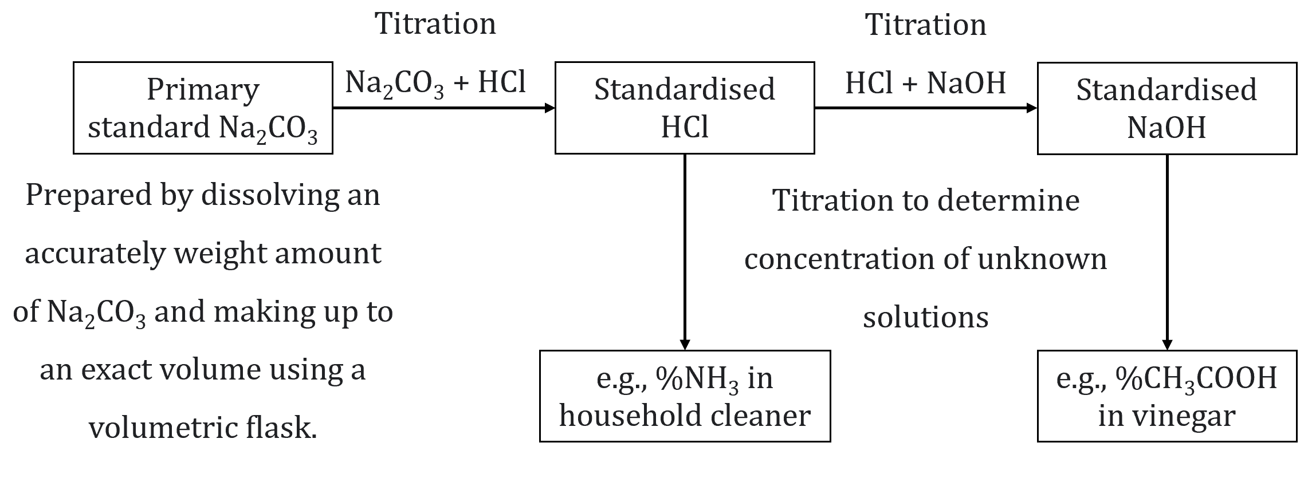

5 main pieces of equipment are used in titrations:

1. Pipette – Used to accurately deliver a known volume (aliquot) of liquid. It’s rinsed with the solution to be delivered from it prior to use.

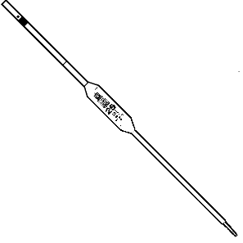

1. Burette – Used to accurately deliver a variable volume (titre) of liquid. It’s rinsed with the solution to be delivered from it prior to use.

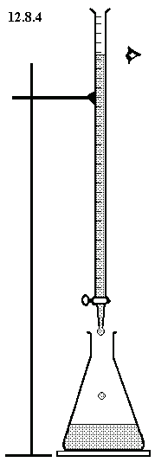

1. Volumetric flask – Used to hold an accurately known volume of solution under the burette(is it right?). It’s rinsed with de-ionised or distilled water prior to use.

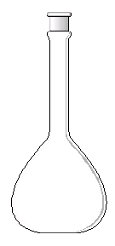

1. Analytical balance – Used to weigh out an accurately known mass.

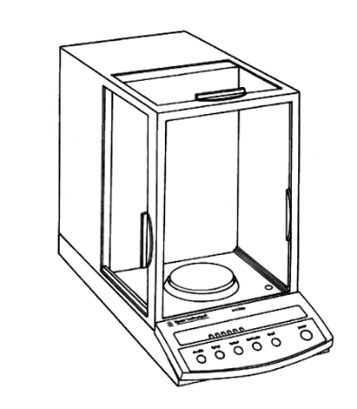

1. Conical flask – Used to hold the solutions during the titration. It’s rinsed with de-ionised or distilled water prior to use.

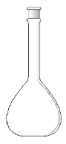

Titration process:

1. An aliquot of the standard solution is added to a conical flask.
2. A titre of the unknown solution is then carefully added from a burette into the conical flask until the reaction between the acid and base is complete.
3. This theoretical point in the titration when neither acid nor base remain is called the equivalence point.
4. The equivalence point occurs when stoichiometrically equivalent amounts of acid and base (reactants) have reacted.

In a back titration, a known volume of an excess reactant is added to the reactant being analysed. A titration is then carried out to determine the amount of excess reactant remaining after the reaction.

**Changes in pH During Acid-Base Titrations**

Running strong acid into strong base:

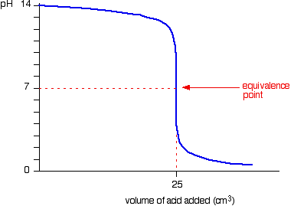

Running strong base into strong acid:

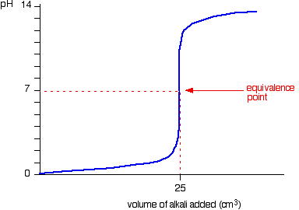

Running strong base into weak acid:

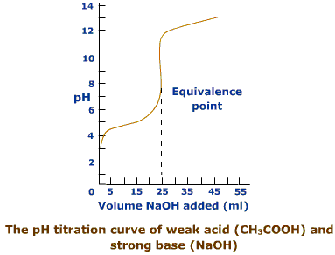

Running strong acid into weak base:

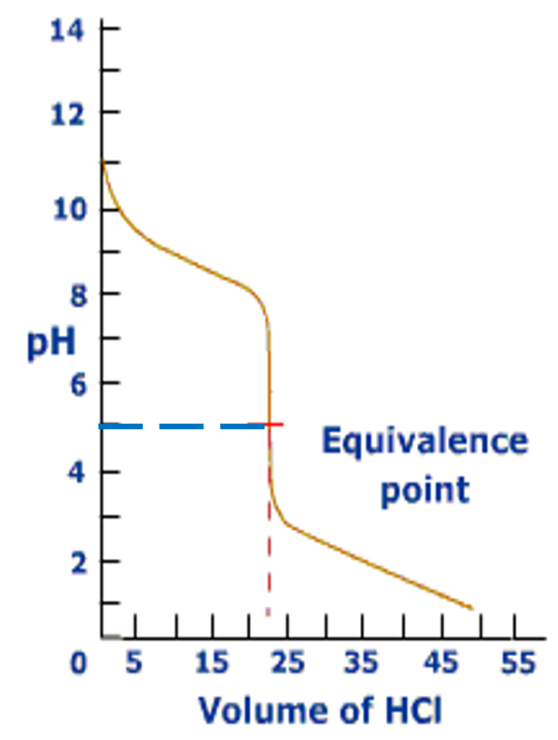

Running weak acid into strong base:

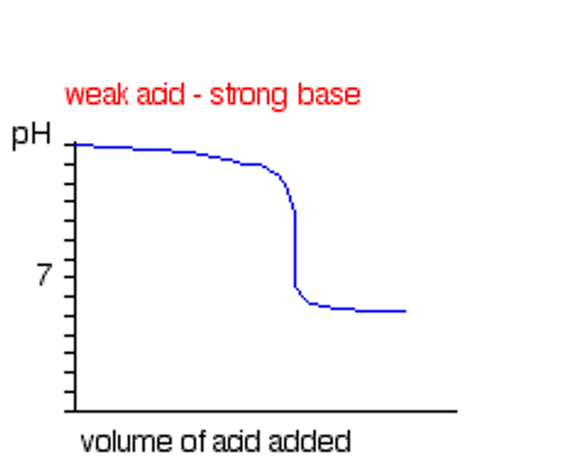

Running weak acid into weak base:

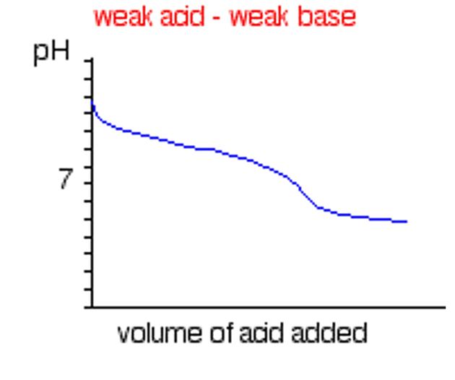

Q: A 1.252g sample of an oven cleaner containing mostly sodium hydroxide was dissolved and made up to 250mL using a volumetric flask. A 20mL aliquot of this solution was titrated against 0.095mol L-1 HCl and required 23.85mL of this acid to reach the end point. Calculate the percentage (by mass) of NaOH in the oven cleaner.

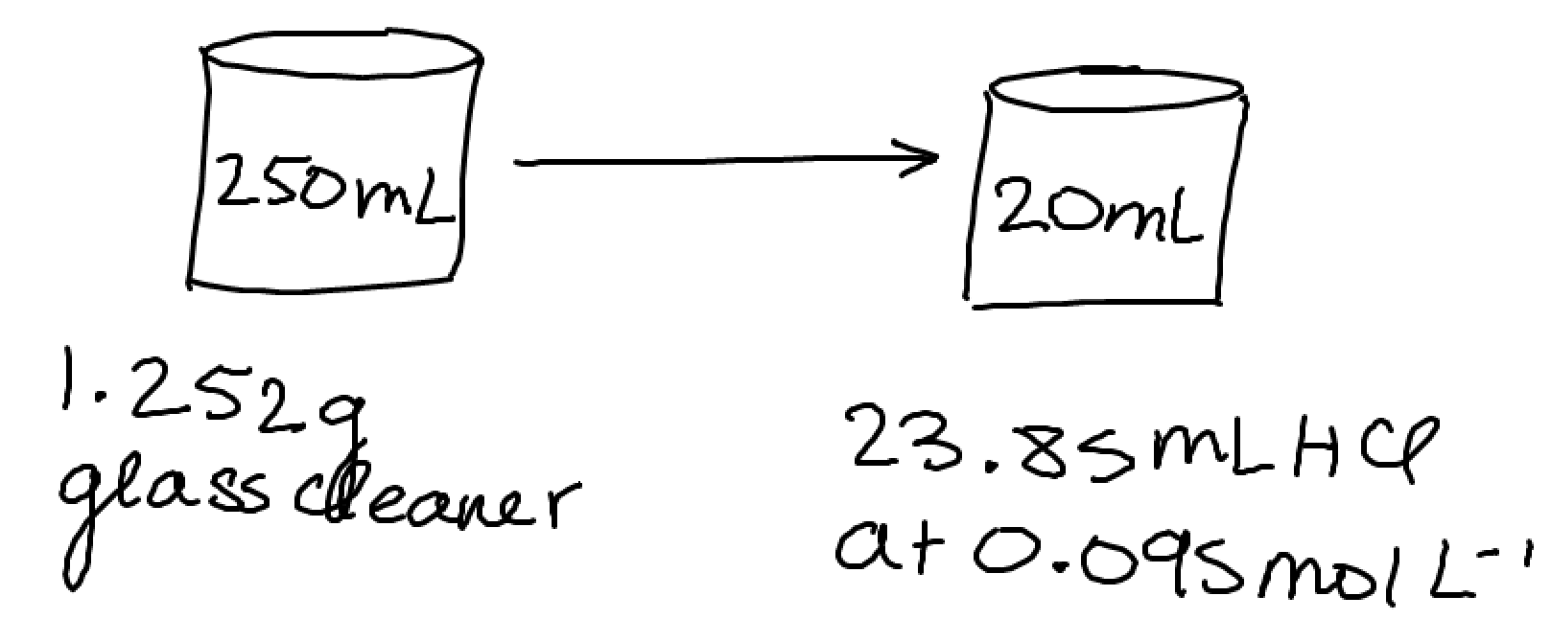

NaOH + HCl → NaCl + H2O

n(HCl) = cV = (0.095)(0.02385) = 0.00227mol

n(NaOH) = n(HCl) = 0.00227mol

n(NaOH) in 250mL = 0.00277 x $\frac{250}{20}$ = 0.0283mol

m(NaOH) in 250mL = nM = (0.0283)(22.99+16+1.008) = 1.133g

%NaOH = $\frac{1.133}{1.252}$ x 100 = 90.5%

STAWA Experiments 12

Method:

1. Calculate the mass of Na2CO3 (m = nM = cVM).
2. Place a little more than the required amount in an oven at 270°C for 30 minutes.
3. Place the Na2CO3 in a desiccator to cool.
4. Put the required mass of Na2CO3 (step 1) into a 250mL beaker.
5. Dissolve the solid in 100mL (some) distilled water.
6. Transfer this solution to a 500mL volumetric flask – rinse the beaker with about 20mL portions of distilled water.
7. Add distilled water to make the solution up to the calibrated mark (last few mL with a pipette).
8. Place the stopper in the volumetric flask and mix the solution thoroughly.
9. Transfer the solution to a clean storage bottle which should be rinsed with a bit of the Na2CO3 solution.

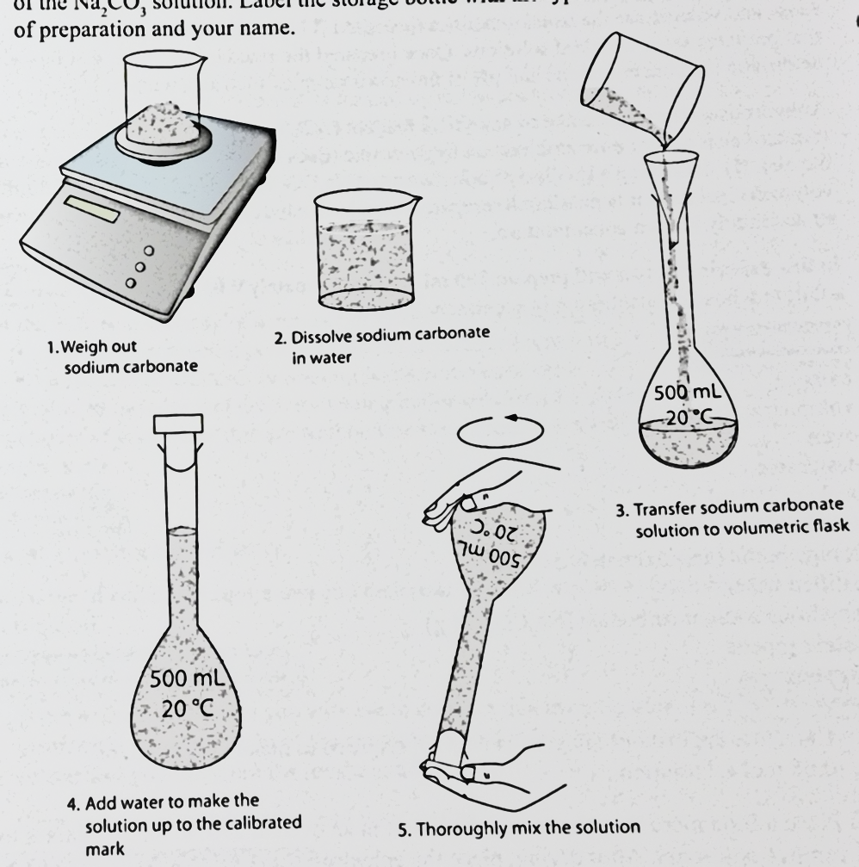

c = $\frac{m({Na}_{2}{CO}_{3})}{M({Na}_{2}{CO}_{3})}*\frac{1}{V}$

Possible errors: Calibration error, evaporation of the Na2CO3 solution.

% error = $\frac{| \left[true value\right]-\left[experimental value\right] |}{[true value]}$ x 100

STAWA Experiment 13

Method – Part A: Making 0.1mol L-1 HCl

1. Calculate volume of concentrated HCl to prepare 500mL of 0.1mol L-1 solution (c1V1 = c2V2).
2. Transfer this volume of concentrated HCl to a 500mL volumetric flask that’s about half filled with distilled water (last few mL with pipette).
3. Place the stopper in the volumetric flask and mix the solution thoroughly.
4. Transfer the approximately 0.1mol l-1 HCl to a clean storage bottle that’s been rinsed with a little bit of the HCl solution.

Method – Part B: Standardisation of the HCl solution

1. Place 100mL of standard Na2CO3 solution into a clean beaker. If wet, rinse with a little bit of the Na2CO3 solution first.
2. Rinse a clean 20mL pipette with some of the Na2CO3 solution.
3. Pipette 20mL of Na2CO3 solution into a 250mL conical flask.
4. Rinse a clean burette with some of the HCl solution and then fill the burette with the solution.
5. Add 2-3 drops of your chosen indicator to the flask.
6. Rinse a clean burette with some of the HCl solution and then fill the burette with the solution.
7. Record the level of acid in the burette. Obtain a rough estimate of the titration volume by running acid quickly from the burette while constantly swirling the liquid in the conical flask. Stop delivery of acid as soon as permanent colour change is obtained.

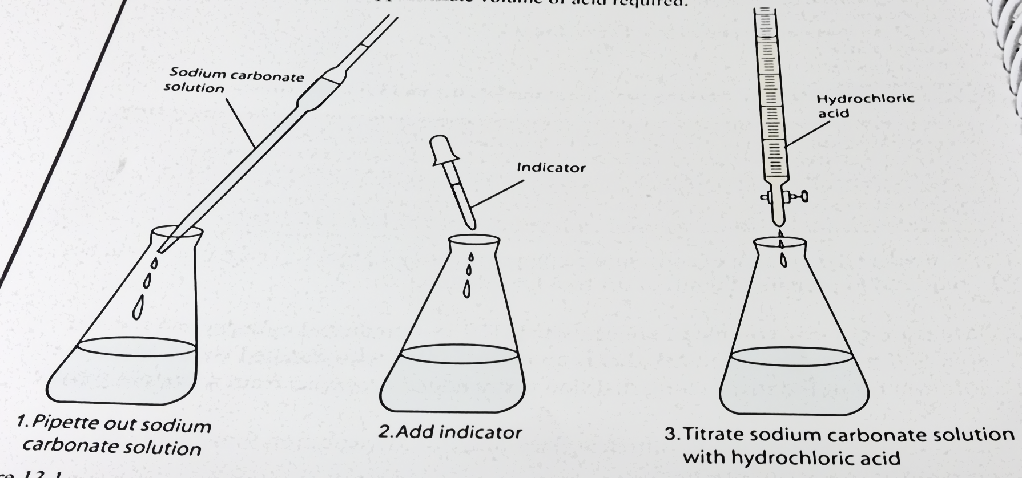

1. Table of results:

|  |  |  |  |  |
| --- | --- | --- | --- | --- |
|  | Rough estimate | Accurate titrations | | |
|  |  | 1 | 2 | 3 |
| Final reading (mL) |  |  |  |  |
| Initial reading (mL) |  |  |  |  |
| Titre (mL) |  |  |  |  |

1. Prepare another conical flask containing a 20mL aliquot of the Na2CO3 solution and 2-3 drops of indicator. This time add the acid quickly from the burette with constant swirling of the flask until the volume added is within 2-3mL of the approximate volume required. Rinse the inside of the conical flask with a jet of distilled water to return any splashed solution to the bulk solution. Continue adding acid drop by drop and with constant swirling until the addition of one drop is sufficient to produce permanent colour change. Note and record the level of the acid in the burette at the end point.
2. Repeat the accurate titration with further 20mL aliquots of Na2CO3 solution until consistent titration volumes are obtained. These should be within 0.2mL of each other.

STAWA Experiment #13 – acidic end point → methyl orange.

STAWA Experiment #14 – neutral end point → bromothymol blue.

STAWA Experiment #15 – basic end point → phenolphthalein.

Rinse burette and pipette with the solution.

Rinse conical flask with water.

STAWA Experiment #15:

NaOH + CH3COOH → CH3COONa + H2O

Part 1:

1. Put vinegar in beaker.
2. Put blue thing on the pipette (shorter side). Brace the pipette.
3. Rinse pipette with vinegar (don’t let it go out the top).
4. Put contents of pipette into a separate beaker.
5. Fill up the pipette until meniscus is on the graduated line (25mL).
6. Wipe the excess vinegar off the surface of pipette.
7. Take blue thing off and immediately seal the top hole with thumb.
8. Roll thumb to one side until meniscus is on graduated line if not already.
9. Put vinegar in volumetric flask.
10. Make the pipette at an angle to the vertical volumetric flask.
11. Count to 3 at the end (some left is normal).
12. Rinse the volumetric flask down with some distilled water (long tube).
13. Fill volumetric flask with distilled water until meniscus is under graduated line (500mL) (without long tube).
14. Last few mL with pipette until meniscus is on the graduated line.
15. Put stopper on volumetric flask and mix it around (inverting) (keep stopper on it).

Part 2:

1. Rinse burette with a bit of vinegar solution.
2. Put contents of pipette into the same separate beaker as initially.
3. Fill the burette with vinegar (with glass funnel) until above the zero mark.
4. Record initial reading on burette (doesn’t have to be exactly at zero) (0.50).

Part 3:

1. Fill pipette with NaOH until above the graduated line (20mL).
2. Put NaOH into separate beaker until meniscus is on graduated line.
3. Put NaOH solution in conical flasks that are already rinsed with NaOH solution from beaker.
4. Count to 3 at the end (some left is normal).
5. Wipe excess solution off the surface of the pipette.
6. Add 2 drops of phenolphthalein into conical flask of NaOH and of (rough titration?).
7. Put burette filled with vinegar into conical flask filled with NaOH until one more drop would result in permanent colour change.
8. Record final reading on burette (28.70).

Part 4:

1. Fill burette with vinegar solution until around the 26mL mark.
2. Record initial reading of burette filled with the vinegar solution (1.30).
3. Fill the other flask (with phenolphthalein) with the vinegar from burette until one more drop would result in permanent colour change (around 27).
4. Record final reading on burette (28.80).

|  |  |  |  |  |
| --- | --- | --- | --- | --- |
|  | Rough titration | Accurate titrations | | |
|  |  | 1 | 2 | 3 |
| Initial reading (mL) |  |  |  |  |
| Final reading (mL) |  |  |  |  |
| Titre  (mL) |  |  |  |  |

|  |  |  |  |  |
| --- | --- | --- | --- | --- |
|  | Rough titration: | Titration 1: | Titration 2: | Titration 3: |
| Initial reading (mL) |  |  |  |  |
| Final reading (mL) |  |  |  |  |
| Titre (mL) |  |  |  |  |

Q: What’s the effect on the calculated concentration when using the wrong indicator?

If you use the wrong indicator, then the equivalence point will be reached earlier or later depending on where the equivalence point is reached and the type of indicator used.

The primary standard, Na2CO3, is basic. As the standard solution, HCl, is added, the pH progressively decreases with an equivalence point in the acidic range, since a strong acid is being added to a weak base. If bromothymol blue is used as an indicator, which has a neutral point, then the end point of the indicator will be reached too early, underestimating the volume of HCl required, hence increasing the calculated [HCl] as concentration is inversely proportional to volume.

You can’t use NaOH as a primary standard because NaOH absorbs a lot of moisture from the atmosphere. That’s why we have to use Na2CO3 to determine the

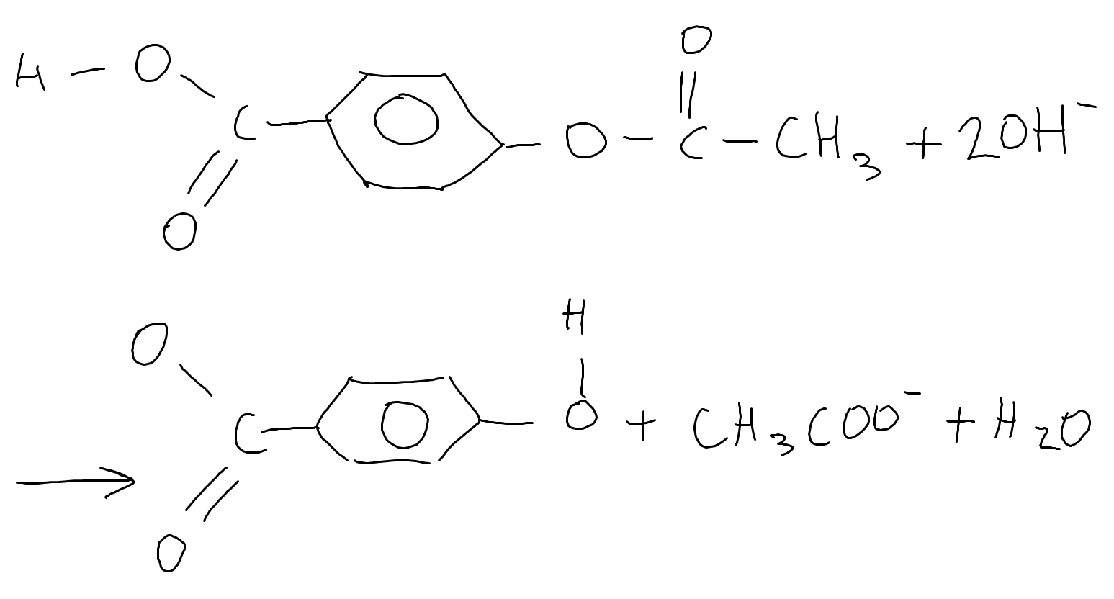

An analysis of Aspirin involves a back titration where NaOH is used to react with the –COOH group and the –C=O group in the molecule shown above.

A 2.00g Aspirin tablet was crushed and then boiled with 150.0mL of 4.52 x 10-1mol L-1 NaOH solution until dissolved. A 20.0mL aliquot of the solution was then titrated with a HCl solution and required 17.65mL to reach the endpoint. Earlier, 25.0mL of the HCl solution was titrated against a standard 1.62 x 10-1mol L-1 Na2CO3 solution and required 28.9mL to reach the endpoint. Calculate the percentage purity of the Aspirin tablet.

[11 marks]

1. Find n(HCl) in the 25mL of HCl via Na2CO3 + 2HCl → 2NaCl + H2O + CO2.
2. Find n(HCl) in the 17.65mL of HCl from step 1.
3. State that n(HCl) = n(NaOH) via NaOH + HCl → NaCl + H2O.
4. Find n(NaOH)reacted in the 150mL solution from step 3 with (initial – excess).
5. State that n(OH–) = n(NaOH).
6. Find n(aspirin) = n(OH–)/2 from the given equation.
7. Find m(aspirin) = n(aspirin) x M(aspirin).
8. Find % mass.

Na2CO3 + 2HCl → 2NaCl + H2O + CO2

n(Na2CO3) = 0.162 x 0.0289 = 0.00468mol

n(HCl) in 25mL = 2 x n(Na2CO3) = 0.00936mol

n(HCl) in 20mL = 0.00936 x $\frac{17.65}{25}$ = 0.00661mol

NaOH + HCl → NaCl + H2O

n(NaOH) in 20mL = n(HCl) = 0.00661mol

n(NaOH) in 150mL = 0.00661 x $\frac{150}{20}$ = 0.0496mol

n(NaOH) reacted = n(NaOH) initial – n(NaOH) excess = 0.0182mol

n(acid) = $\frac{n({OH}^{-})}{2}$ = 0.00911mol

m(acid) = 1.64g

% mass = $\frac{1.64}{2}$ x 100 = 82.1%

Q: Name a suitable indicator that could’ve been used in the titration between HCl and Na2CO3. Justify your choice using appropriate chemical equations.

[6 marks]

Methyl orange.

The salt produced is NaCl from the titration.

2HCl (aq) + Na2CO3 (aq) → 2NaCl (aq) + H2O (l) + CO2 (g)

As HCl is a strong acid and Na2CO3 is a weak base, the resulting salt is neutral. However, the CO2 gas reacts with water, resulting in the formation of H2CO3.

CO2 (aq) + H2O (l) → H2CO3 (aq)

H2CO3 then undergoes hydrolysis, forming H3O+ ions.

H2CO3 (aq) + H2O (l) → CO32–(aq) + 2H3O+(aq)

The increase in [H3O+] means the solution is slightly acidic as [H3O+]>[OH–]. As such, methyl orange is a suitable indicator as it changes colour in the range 3.0–4.5 (you can approximate 3.0–4.5 as the pH range for both methyl orange and bromophenol blue).

Theory Past Exam Questions

**WACE 3AB 2010 Q28:**

Like water, ammonia is able to react with itself, in the process known as ‘self-ionisation’. The equation for the self-ionisation of ammonia is below.

NH3(aq) + NH3(aq) ⇌ NH4+(aq) + NH2-(aq)

1. Identify the conjugate acid and base pairs in the reaction. Join each pair with a line, and label the conjugate acid and base of each pair appropriately. (1 mark)

NH3(aq) + NH3(aq) ⇌ NH4+(aq) + NH2-(aq)

1. At standard temperature and pressure, the equilibrium constant, K, for this reaction is about 1 x 10-30. The self-ionisation of ammonia is an endothermic process. Will the value of K be less than or greater than 1 x 10-30 at temperatures greater than 0 °C? Explain. (3 marks)

The reaction is endothermic.

Hence at T>0°C (the temperature for which the equilibrium constant is given) the forward reaction will be favoured.

This means the concentration of products will increase relative to reactants, meaning the K value will increase, meaning the K value will be greater than 1 x 10–30.

**WACE 2AB 2014 Q38:**

1. Write an ionic equation for the reaction between phosphoric acid and barium hydroxide solution. Include state symbols. (3 marks)

3Ba(OH)2 (aq) + 2H3PO4 (aq) → Ba3(PO4)2 (aq) + 6H2O (l)

6OH–(aq) + 6H+(aq) → 6H2O (l)

1. Phosphoric acid is a polyprotic acid. With the aid of equations, use phosphoric acid as an example to explain the term ‘polyprotic’ (4 marks)

A polyprotic acid is an acid with more than one proton/H+ ion available for ionisation.

H3PO4, a polyprotic acid, has 3 donatable hydrogens and hence can undergo 3 consecutive ionisation reactions, each donating one H+ ion.

H3PO4 (aq) + H2O (l) ⇌ H3O+(aq) + H2PO4–(aq)

H2PO4–(aq) + H2O (l) ⇌ HPO42–(aq) + H3O+(aq)

HPO42–(aq) + H2O (l) ⇌ PO43–(aq) + H3O+(aq)

1. Phosphoric acid is a weak acid and a weak electrolyte. Barium hydroxide is a strong base and a strong electrolyte. Using equations containing phosphoric acid and barium hydroxide, explain the difference between the terms ‘strong’ and ‘weak’ when referring to electrolytes. (4 marks)

A strong electrolyte (e.g., Ba(OH)2) fully ionises in solution, resulting in a completely ionic solution.

Ba(OH)2 (aq) → Ba2+(aq) + 2OH–(aq)

A weak electrolyte (e.g., H3PO4) partially ionises in solution, resulting in a solution containing both ionic products and the original reactant.

H3PO4 (aq) ⇌ 3H+(aq) + PO43–(aq)

**WACE 2AB 2011 Q30:**

The poisonous compound oxalic acid (H2C2O4) is found in significant quantities in the leaves of the rhubarb plant, while its stalks contain only trace amounts, making them safe to eat. Oxalic acid is a polyprotic acid.

1. Explain what is meant by the term ‘polyprotic’. (1 mark)

* **1 mark:** Acid with more than one ionisable/’donatable’ proton/H+

1. Complete the table below by giving appropriate formulae. (2 marks)

|  |  |
| --- | --- |
| **Substance** | **Example** |
| A polyprotic acid (other than oxalic acid) | **Any polyprotic acid. E.g. H2SO4, H3PO4** |
| A monoprotic acid | **Any monoprotic acid. E.g. HCℓ, HNO3** |

1. Write the equations for the successive ionisation of oxalic acid. (2 marks)

H2C2O4 (aq) + H2O (l) ⇌ HC2O4–(aq) + H3O+(aq)

HC2O4–(aq) + H2O (l) ⇌ C2O42–(aq) + H3O+(aq)

1. Explain why a 0.1 mol L-1 solution of oxalic acid would have a higher pH than a 0.1 mol L-1 solution of sulfuric acid. (2 marks)

A strong acid e.g., H2SO4 will fully ionise in solution whereas a weak acid e.g., H2C2O4 will partially ionise in solution.

Hence the full ionisation of H2SO4 will result in a greater [H+] than the partial ionisation of H2C2O4 despite both acids being diprotic.

**HSC 1996 Q25:**

Understanding of acids and bases has changed since Arrhenius first developed his theory. Although an acid-base reaction is known as neutralisation, the resulting salt solution is not always neutral. For example, a solution of the salt sodium sulfate is neutral, but a solution of sodium ethanoate (acetate) is basic.

1. Write an equation to describe the formation of sodium sulfate from an acid-base reaction. Name the reactants. (2 marks)

2NaOH (aq) + H2SO4 (aq) → Na2SO4 (aq) + 2H2O (l)

Reactants: Sodium hydroxide, sulfuric acid.

1. Explain why a solution of sodium ethanoate (CH3COONa) is basic, which a sodium sulfate solution of the same concentration has a pH of 7.0. Write ionic equations to describe any reactions. (4 marks)

CH­3COONa:

Na+ ion is neutral whereas CH3COO– ion is basic.

CH3COO–(aq) + H2O (l) ⇌ CH3COOH (aq) + OH–(aq)

The increase in [OH–] causes pH to increase above 7, creating a basic solution.

Na2SO4:

Na+ ion and SO42– ion are both neutral.

Neither undergoes hydrolysis and so there’s no change in pH.

**TEE 2001 Q5:**

1. A 0.1 mol L-1 solution of Na2HPO4 has a pH of about 10. Explain this, using an equation or equations. (3 marks)

Na+ ion is neutral whereas HPO42– ion is basic.

HPO42–(aq) + H2O (l) ⇌ H2PO4–(aq) + OH–(aq)

The increase in [OH–] causes pH to increase above 7, creating a basic solution.

1. A 0.1 mol L-1 solution of NH4CH3COO (ammonium acetate) has a pH of approximately 7. Explain this, using at least two equations. (3 marks)

NH4+ ion is acidic: NH4+(aq) + H2O (l) ⇌ NH3 (aq) + H3O+(aq)

CH3COO– ion is basic: CH3COO–(aq) + H2O (l) ⇌ CH3COOH (aq) + OH–(aq)

The acidity of the NH4+ ion is countered by the basicity of the CH3COO– ion as both equations have similar K values and hence pH is around 7.

**WACE 3AB 2015 Q40:**

Hydrogen fluoride, HF, is a highly dangerous and corrosive liquid that boils at near room temperature. It readily forms hydrofluoric acid in the presence of water and is an ingredient used to produce many important compounds, including medicines and polymers.

1. The equilibrium constant (K) for the dissociation of hydrofluoric acid is 6.8 x 10-4, and for hydrochloric acid K is very large. To make a solution of hydrofluoric acid with the same pH as hydrochloric acid, a greater concentration of hydrofluoric acid is required. Explain why this is so. (3 marks)

To have the same pH, both acids need to have the same [H+].

HF doesn’t ionise to the same extent as HCl.

Hence a greater [HF] is needed to give the required [H+].

1. The salts, sodium chloride and sodium fluoride, readily dissolve in water. At 25.0 °C the pH of the sodium chloride solution is equal to 7 whereas the pH of the sodium fluoride solution is greater than 7. Explain this difference in pH. Include any relevant equation(s) to support your answer. (3 marks)

Na+ ion is neutral.

Cl– ion is neutral and hence NaCl is neutral.

F– ion is basic and hence NaF is basic.

F–(aq) + H2O (l) ⇌ HF (aq) + OH–(aq)

The increase in [OH–] causes pH to increase above 7, creating a basic solution, creating a basic solution.

**WACE 3AB 2012 Q36:**

Water is able to react with itself in the process known as ‘self-ionisation’ or ‘auto-ionisation’.

1. Write the equation for the self-ionisation of water. (1 mark)

2H2O (l) ⇌ H3O+(aq) + OH–(aq)

1. At 25 °C, the value of Kw is approximately 1.0 x 10-14. At 10 °C, the value of Kw is approximately 2.9 x 10-15. (2 marks)

What are the relative concentrations of H+ and OH- ions in a neutral water solution at **25 °C**?  
Circle the correct answer.

[H+] > [OH-] [H+] < [OH-] [H+] = [OH-]

What are the relative concentrations of H+ and OH- ions in a neutral water solution at **10 °C**?  
Circle the correct answer.

[H+] > [OH-] [H+] < [OH-] [H+] = [OH-]

1. Consider the values of Kw at 10 °C and 25 °C, and state whether the self-ionisation of water is an endothermic or exothermic process. Give a reason to support your answer. (3 marks)

The Kw value is greater at 25°C than at 10°C.

Kw is the ratio of concentration of products to reactants.

Hence the forward reaction is favoured when temperature increases.

According to LCP, the endothermic reaction is favoured when temperature increases.

∴ The self-ionisation of water is an endothermic process.

**TEE 2008 Q9:**

A student was given a 0.100 mol L-1 sulfuric acid solution and a 0.200 mol L-1 hydrochloric acid solution. She tested the pH of the solutions using a pH meter and found that the pH of the sulfuric acid solution higher than that of the hydrochloric acid solution. Explain this observation. Include equations in your answer.  
 (4 marks)

As HCl is a strong acid, its ionisation in solution goes to completion.

HCl (aq) → H+(aq) + Cl–(aq)

[H+] = [HCl] = 0.2mol L-1

H2SO4 is diprotic and undergoes 2 consecutive ionisations. The first goes to completion:

H2SO4 (aq) + H2O (l) → HSO4–(aq) + H3O+(aq)

The second does not:

HSO4–­(aq) + H2O (l) ⇌ SO4–(aq) + H3O+(aq)

If both ionisation reactions went to completion then [H+] = 2 x [H2SO4] = 0.2mol L-1

However, the second one doesn’t go to completion and hence [H+] < 0.2mol L-1

[H+] of H2SO4 is less than [H+] of HCl

∴ pH of H2SO4 is greater than pH of HCl

**WACE 3AB 2015 Q40:**

Propanoic acid, CH3CH2COOH, is a weak monoprotic acid. When 0.500 mol of sodium propanoate (NaCH3CH2COO) is dissolved in 1.00 L of 0.500 mol L-1 propanoic acid at 25.0 °C a buffer solution is formed.

1. (i) Addition of 10.0 mL of 1.00 mol L-1 HCℓ(aq) to this buffer does not significantly change its pH. Explain this observation, including any relevant equation(s). (3 marks)

**CH3CH2COOH + H2O ⇌ CH3CH2COO-(aq) + H3O+(aq)**

**As hydrogen ions are added to the buffer equilibrium, the equilibrium will shift left to use up the added H+ ions**

**Due to the shift in equilibrium, there is very little change to the overall concentration of hydrogen ions, and so the pH change is insignificant**

(ii) State **two** conditions required to ensure that this system has a high buffering capacity. (3 marks)

One: **Equal concentrations of acid and conjugate base**

Two: **High concentrations of acid and conjugate base**

**WACE 3AB 2010 Q29:**

Benzoic acid is found in many berries and some other fruits, and is used as a food preservative. The structure of benzoic acid is shown below. In an aqueous environment, benzoic acid ionises and exists in equilibrium with the benzoate ion.

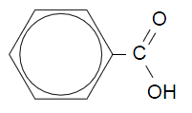

1. Write the equation for the reaction between benzoic acid and water. (1 mark)



1. Draw the structure (either benzoic acid or the benzoate ion) that would predominate in the acidic environment of the stomach. (1 mark)



**Examiner’s comments:** The majority of candidates did not recognise that benzoic acid (rather than benzoate ion) would predominate in the acidic environment of the stomach; perhaps candidates decided that the acidic environment of the stomach would push the equilibrium to the right.

1. Show, using equations and the principles of equilibrium, how a solution of benzoic acid and the benzoate ion may behave as a buffer. (3 marks)

**When H+ is added it will react with benzoate. This consumes the added H+, meaning no significant changes to [H+] or pH**

**C6H5COO-(aq) + H3O+(aq) ⇌ C6H5COOH(aq) + H2O(ℓ)**

**When OH- is added it will react with benzoic acid. This consumes the added OH-, meaning no significant changes to [OH-] or pH**

**C6H5COOH(aq) + OH-(aq) ⇌ C6H5COO-(aq) + H2O(ℓ)**

**HSC 2015 Q24:**

1. Explain why the salt, sodium acetate, forms a basic solution when dissolved in water. Include an equation in your answer. (2 marks)

Na+ ion is neutral whereas CH3COO– ion is basic.

CH3COO–(aq) + H2O (l) ⇌ CH3COOH (aq) + OH– (aq)

The increase in [OH–] causes pH to increase, creating a basic solution, creating a basic solution.

1. A solution is prepared by using equal volumes and concentrations of acetic acid and sodium acetate.

Explain how the pH of this solution would be affected by the addition of a small amount of sodium hydroxide solution. Include an equation in your answer. (3 marks)

CH3COOH­ (aq) + H2O (l) ⇌ CH3COO–(aq) + H3O+(aq

The added OH– causes [H3O+] to decrease.

According to LCP, this causes the forward reaction to be favoured which produces H3O+, and the equilibrium shifts right until a new equilibrium is established, minimising the change in pH.

**HSC 2013 Q25:**

An indicator is placed in water. The resulting solution contains the green ion, *Ind–*,and the red molecule, *HInd*.

Explain why this solution can be used as an indicator. In your response, include a suitable chemical equation that uses *Ind–* and *Hind*. (4 marks)

An indicator needs to change colour in different pH conditions.

Ind–(aq) + H2O (l) ⇌ HInd (aq) + H3O+(aq)

Green Red

When a base is present, [H3O+] is reduced. This causes the equilibrium to shift right, increasing [HInd], and hence the red colour dominates.

When an acid is present, [H3O+] is increased. This causes the equilibrium to shift left, increasing [nd–], and hence the green colour dominates.

**WACE 2016 Sample Exam Q34:**

Ocean acidification results from carbon dioxide dissolving in water and an equilibrium being established between the water and carbon dioxide to produce carbonic acid (H2CO3).

1. Write a balanced equation for this equilibrium. (2 marks)

CO2 (aq) + H2O (l) ⇌ H2CO3 (aq)

1. The formation of carbonic acid leads to an increase in the hydronium ion (H3O+) concentration in the water. Show the equilibrium that results in the formation of hydronium ions when carbonic acid reacts with water. (1 mark)

H2CO3 (aq) + H2O (l) ⇌ HCO3–(aq) + H3O+(aq)

1. State **one** problem that ocean acidification is causing for marine organisms. Explain how this problem arises and support your answer with an appropriate balanced equation. (3 marks)

HCO3–(aq) + H2O (l) ⇌ CO32–(aq) + H3O+(aq)

An increase in [CO2] causes the equilibrium in (a) to shift right, causing [H2CO3] to increase. This causes the equilibrium in (b) to shift right, increasing [H3O+]. This causes the equilibrium in (c) to shift left, decreasing [CO32–].

A decrease in [CO32–] makes it difficult for marine organisms to develop CaCO3 structures e.g., shells, exoskeletons, etc.

**HSC 2015 Q28:**

The equipment shown is set up. After some time a ring of white powder is seen to form on the inside of the glass tube.



1. Why would this NOT be an acid-base reaction according to Arrhenius? (1 mark)

The reaction doesn’t occur in an aqueous solution.

1. Explain why this would be considered a Brønsted-Lowry acid-base reaction. Include an equation in your answer. (2 marks)

The reaction involves a Brønsted-Lowry acid (HCl) and a Brønsted-Lowry base (NH3).

HCl (aq) + NH3 (aq) ⇌ NH4Cl (aq)

2021 Creelman:

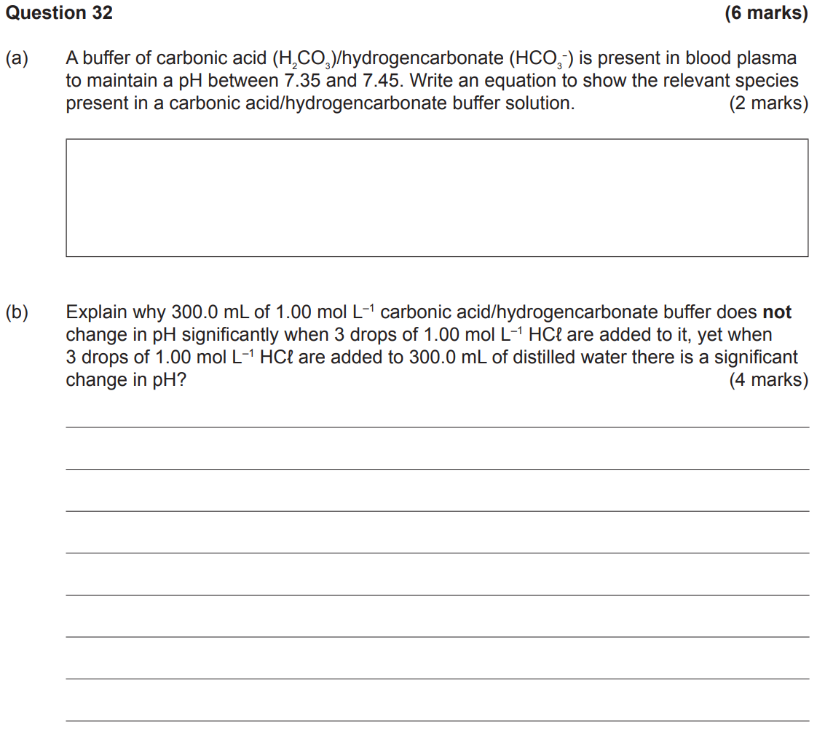

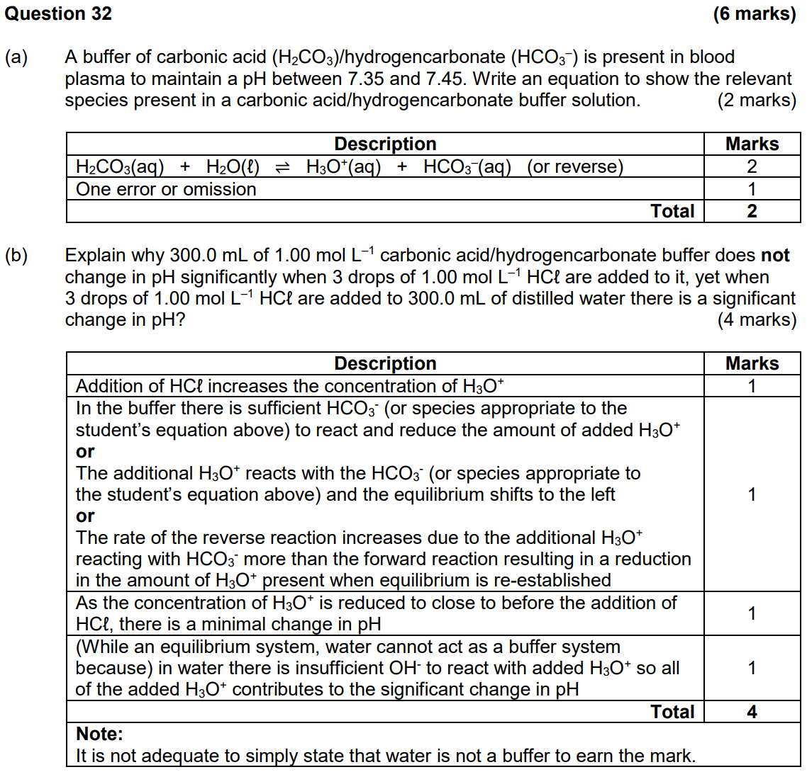



Adding acid to the buffer solution increases [H3O+], decreasing the distance between product particles. This increases the proportion of collisions on the RHS, increasing the rate of the reverse reaction relative to the forward reaction. This decreases [H3O+]. Equilibrium is then re-established. Since [H3O+] is decreased to close to the original value, pH is maintained.

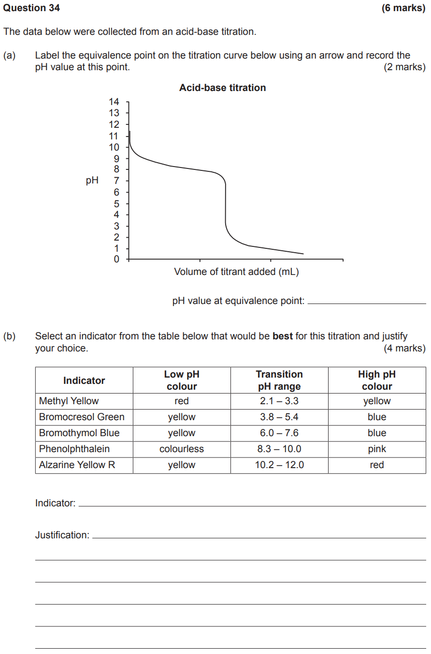

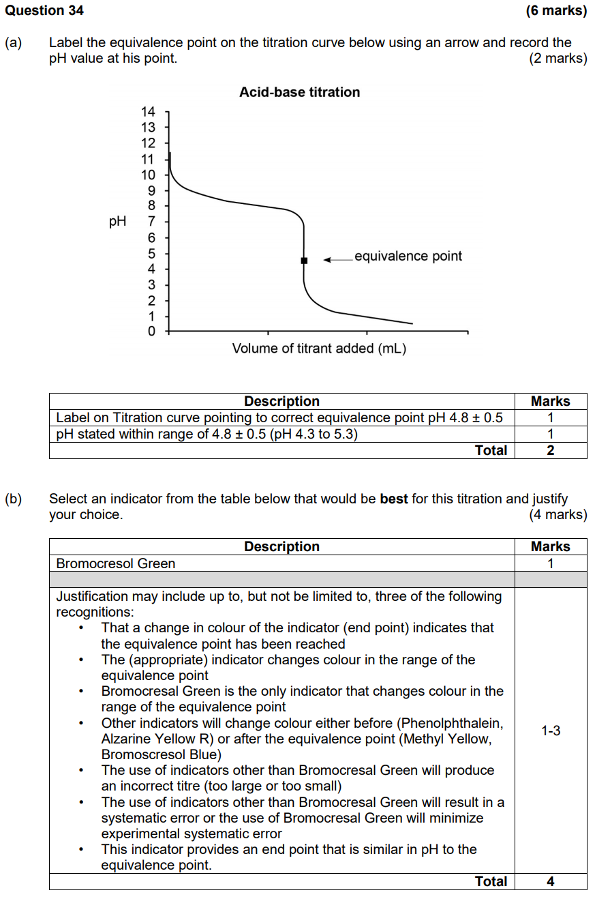

Bromocresol green.

A change in colour of the indicator (end point) indicates that the equivalence point has been reached. The appropriate indicator changes colour in the pH range of the equivalence point. Bromocresol green is the only indicator that changes colour in the pH range of the equivalence point. Other indicators will change colour before or after the equivalence point, resulting in an incorrect titre.

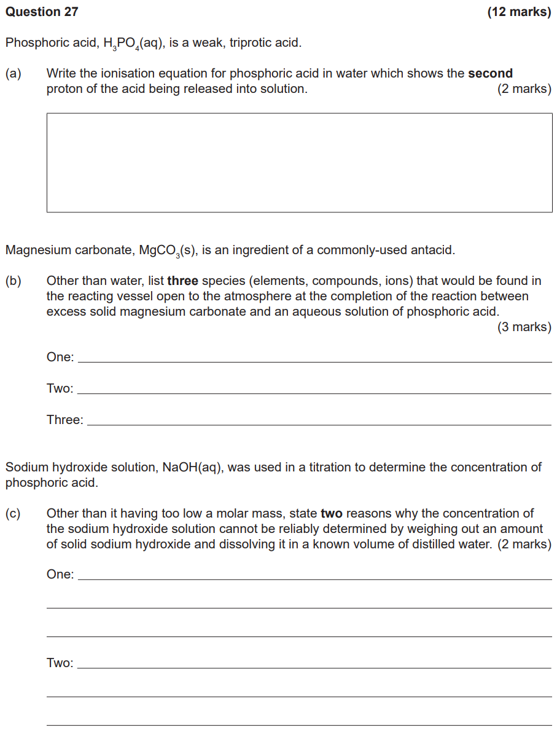

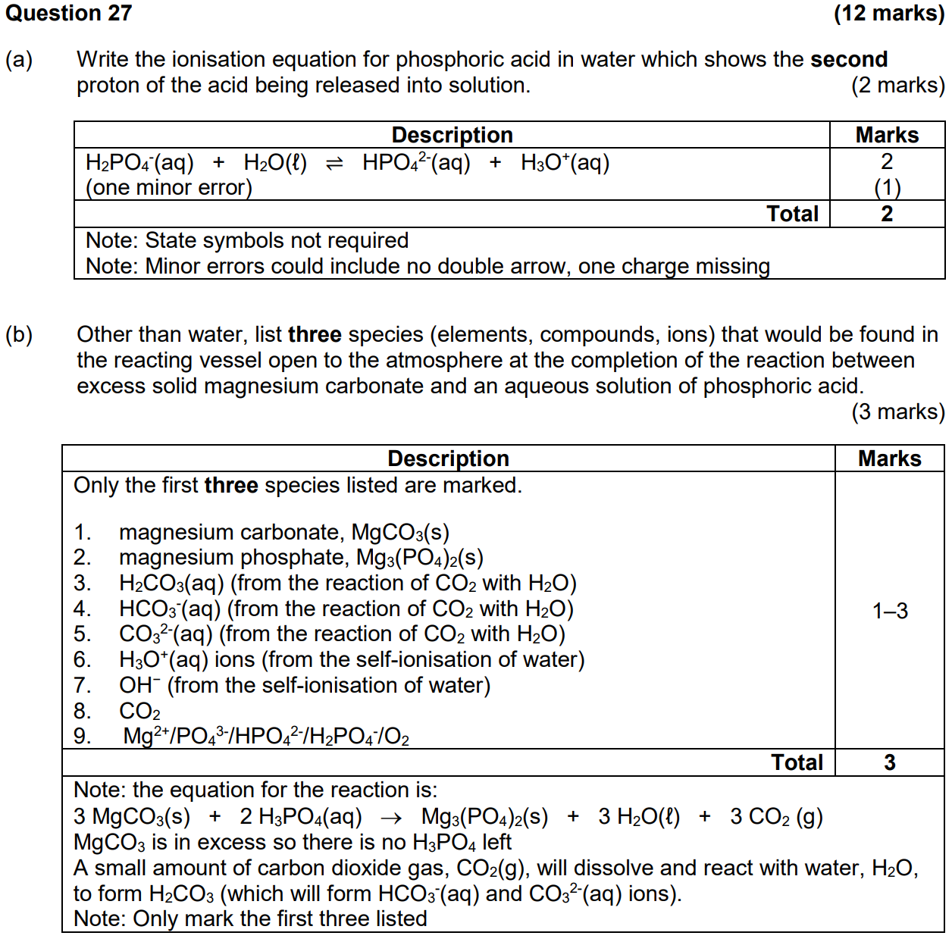

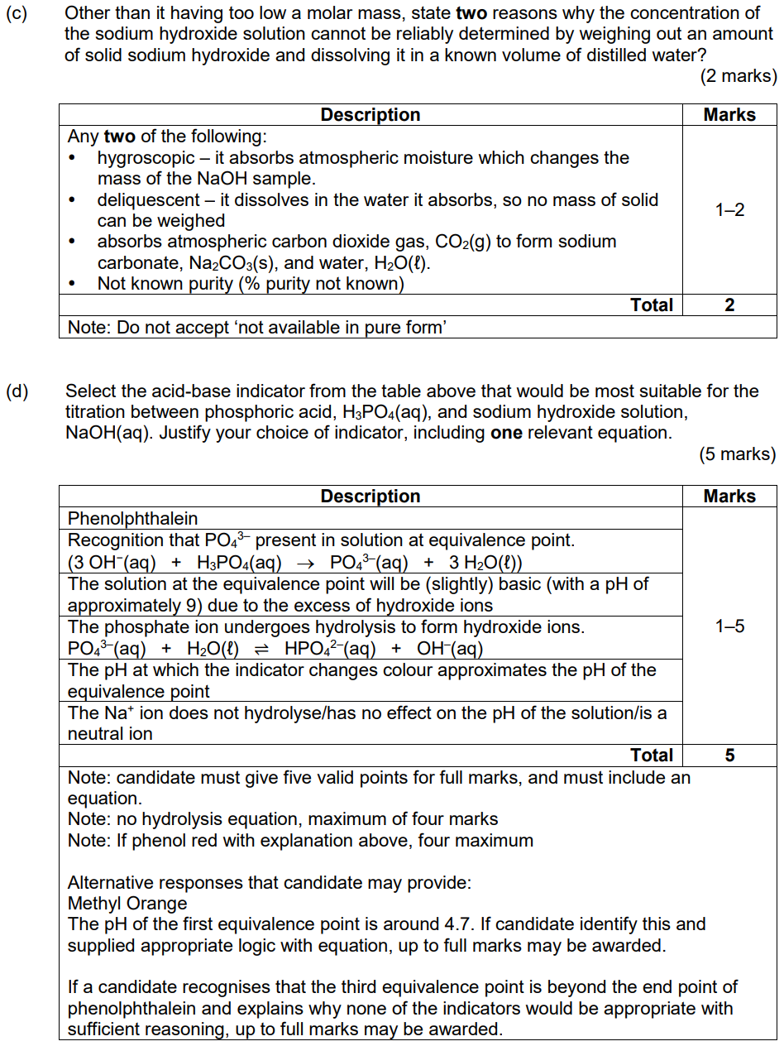

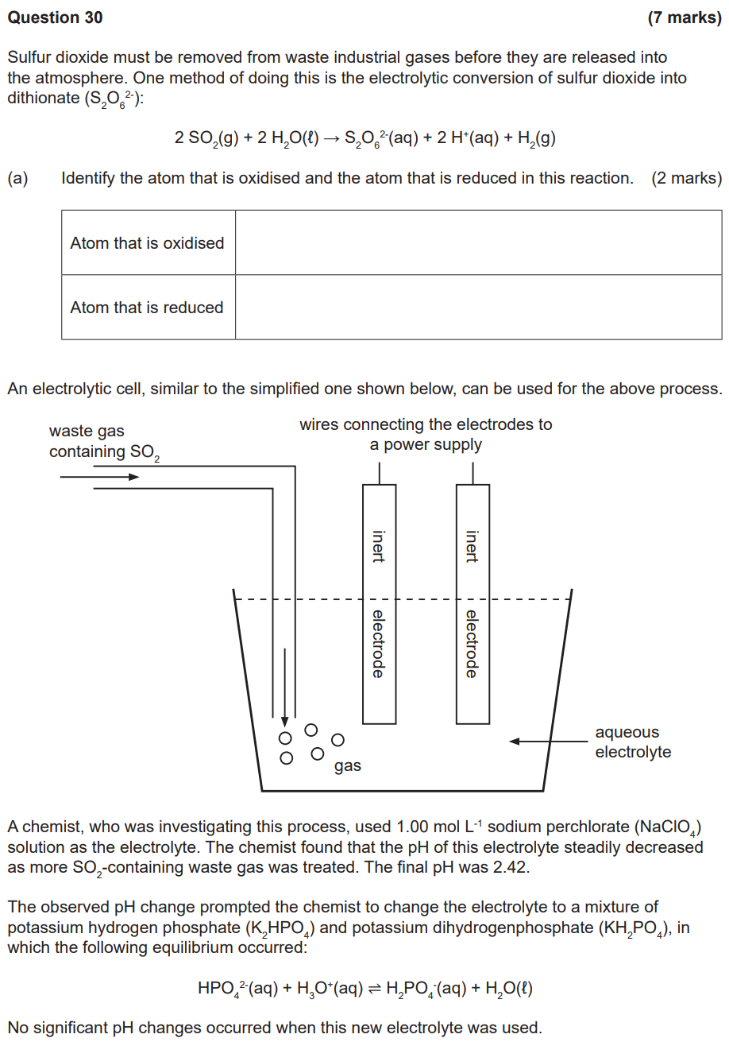

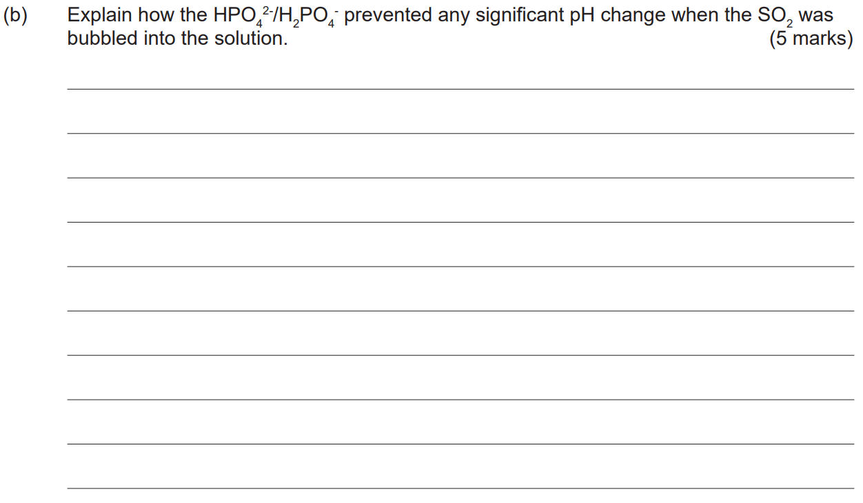

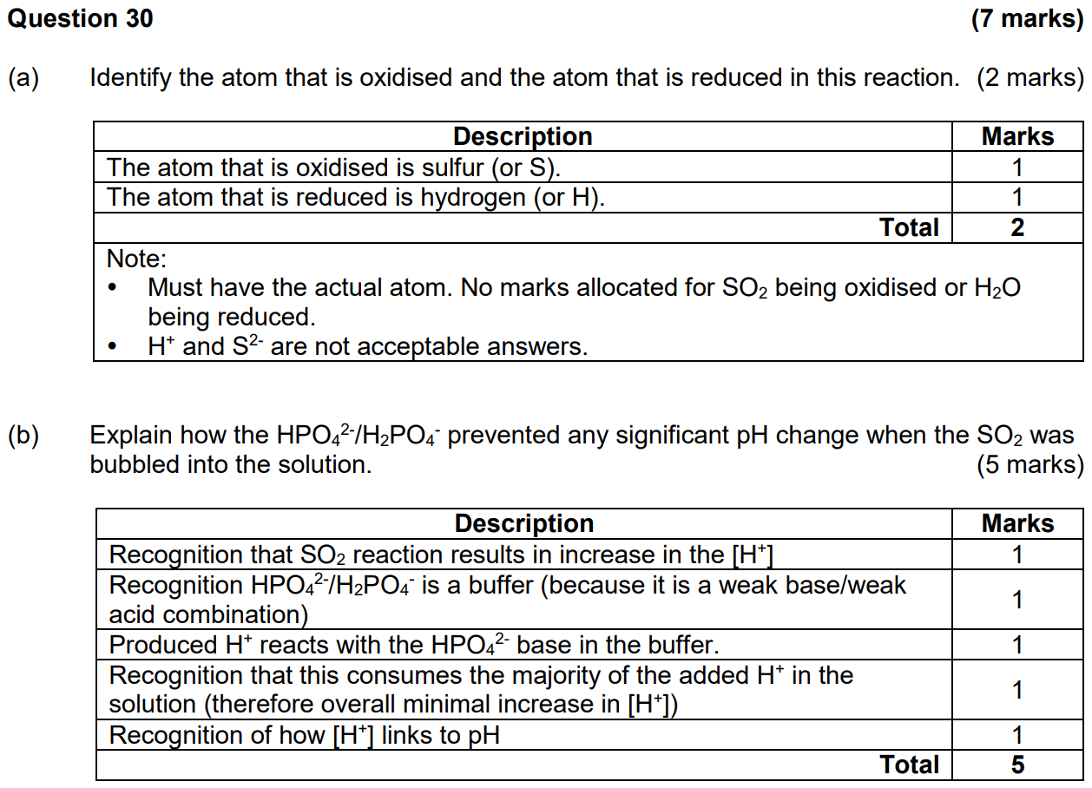

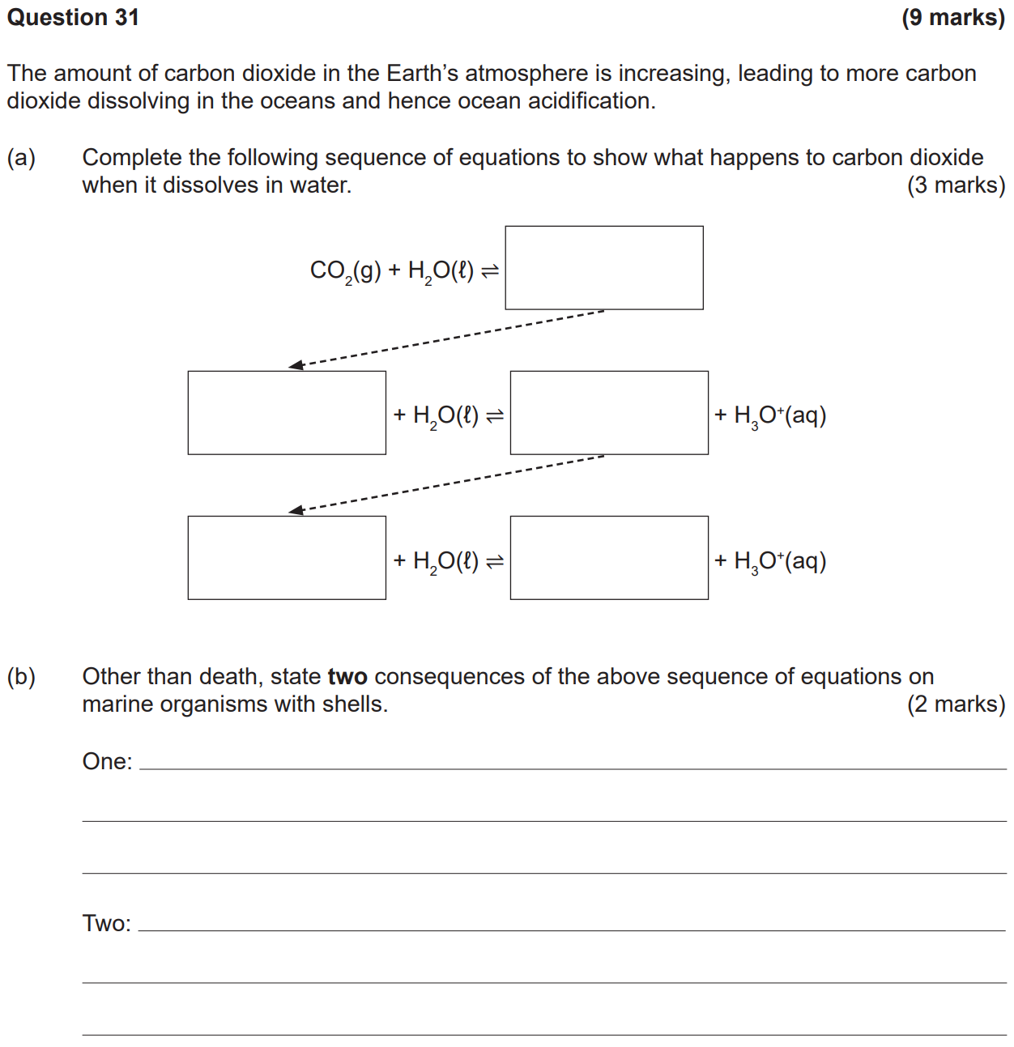

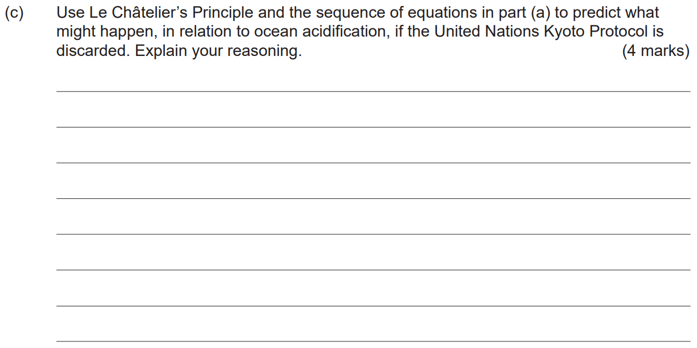

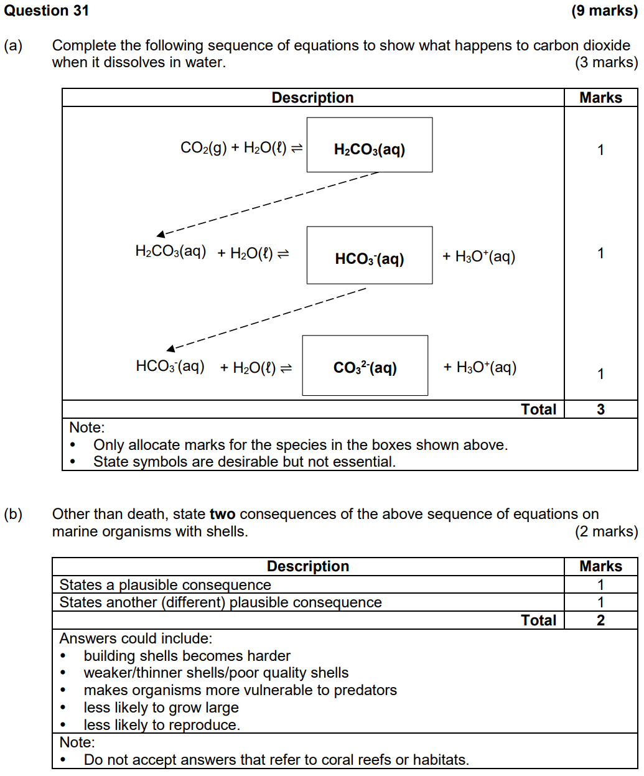

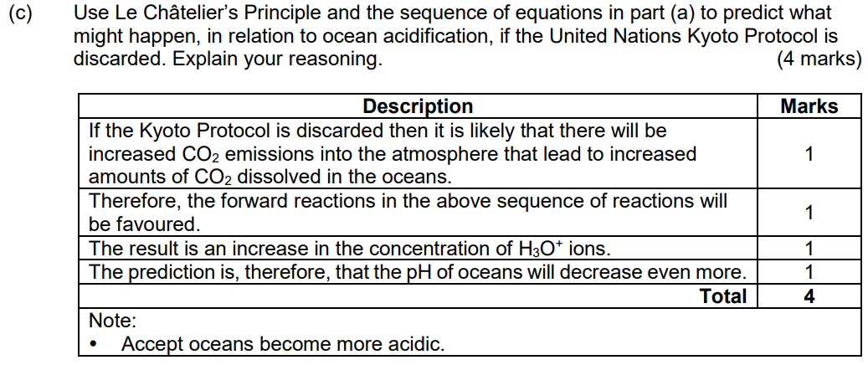

2017 Creelman:

